EGOFETs Fabrication Protocol

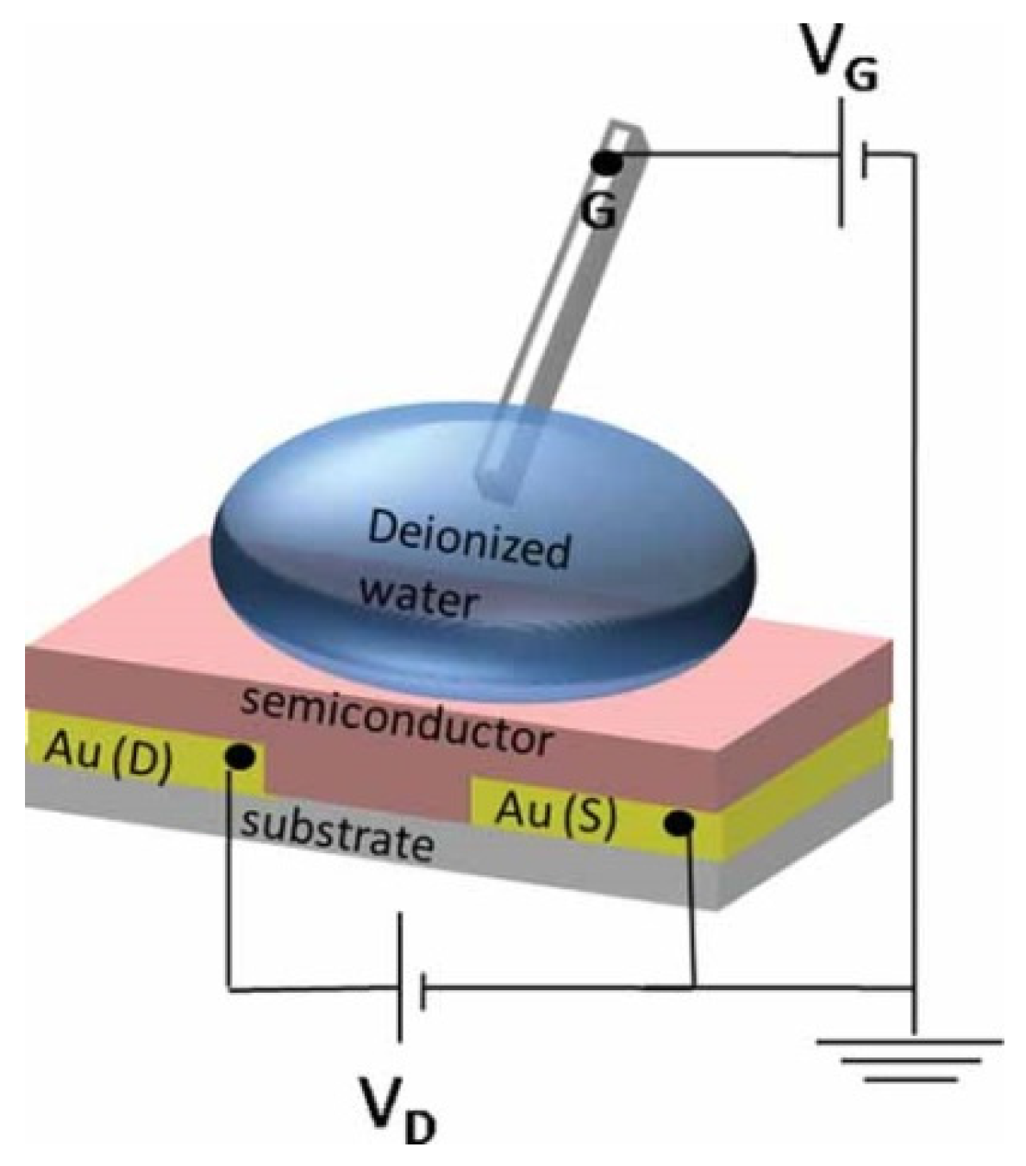

2023

GENERAL CONSIDERATIONS
- EGOFETs are quite sensitive to humidity, so, avoid to leave the devices on air. After being completed fabricated, it is recommended to storage in vacuum (such as vacuum chamber or glovebox).
- Once the device is filled with the dielectric (aqueous solution), it is important not to dehydrate them.

PHOTOLITOGRAPHY

Substrate cleaning
EGOFETs are mainly fabricated on flexible substrates. The most common used in the group is Kapton. There are several thickness (75,125 o 150 µm) available, ones come from a big roll (75) and others in DIN-A4 foils (125).
TIP: Some days (2-3) before using the 75µm substrate, cut the pieces of the desired size from the big roll and set it stretched in a flat site just to avoid ridges or wrinkles on the substrate.
Clean the substrate (Kapton, Si/SiO₂, etc.) as follow:
- Rinse with Acetone
- Rise with Isopropanol
- Drying with Nitrogen Gun

Carrier
If the substrate employed is flexible (Kapton), you must use a carrier to perform the exposition. Commonly, the carrier employed is a Silicon Wafer (4 x 4 inch/ 10x10cm for a 7x7cm flexible substrate).
TIP: Use two different wafers for the carriers: One to do the photolithography (resine deposition) and other for evaporation procedure.
There are several ways to attach the Kapton on the carrier. One of the most suitable (and easiest) is the following:
OBS: The substrate either the carrier must be completed dry! Try to avoid humidity between kapton – carrier interface.
OBS2: The adhesive does not need to cover all the surface of the foil. It is recommended to leave some gaps in order to allow air to go out during the evaporation procedure.
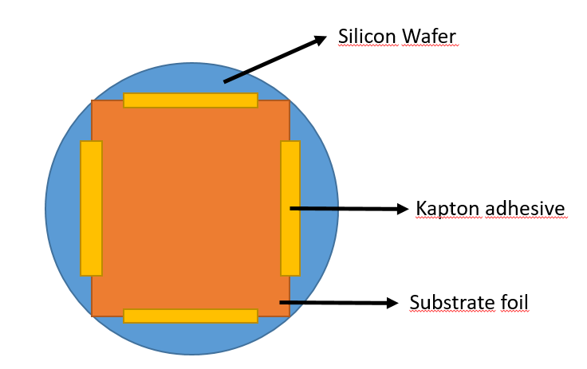

1.3 Photoresin deposition
Deposition method: Spin coater from cleanroom.
- Clean the coater and the support with acetone.
- The support must be fixed with the angel screwdriver. Besides, a square of double – tape is put on it to be sure that the wafer won not move.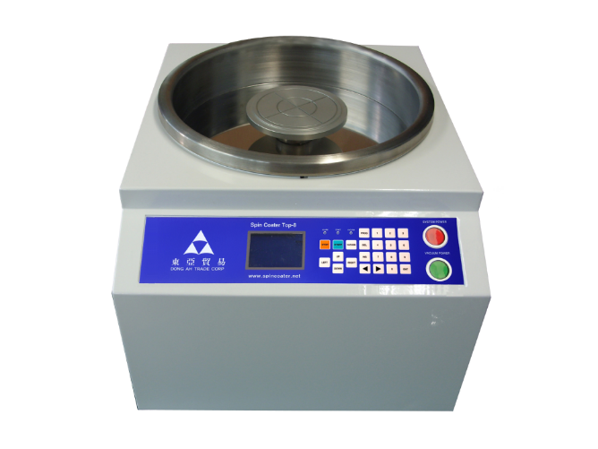
Screwdriver
- The coating parameters are: 4000rpm/s (P15 must be on 0.7), 5000 prm (P16 must be on 83.30%), 25 seconds.
- The wafer is deposited on the center of the support and vacuum need to be created again between the support and the wafer in order to fix the wafer, it is maintained for the whole process.
- The resin (SHIPLEY S1813) is manually deposited on the wafer’s surface and must cover it completely (attention to bubbles! Recommendation: pour the resin directly without the help of the pipette). After the deposition of the resin, we must immediately activate the rotation pressing START. Once the deposition process is done, remove the wafer very carefully, it is very fragile. NOTE: if the deposition process goes wrongly, the wafer can be reused again by cleaning with acetone (take care of scratches).
- Anneal the resin by putting the wafer on the hot plate at 75 ºC for 1 min.
- Introduce the carrier with the sample into the Microwriter.

Laser writing
See notes and training provided by the technicians to use the software.

Developing
- Remove the flexible foil from the silicon wafer. Be very carefull not to bend it!
- Reveal the pattern on the resin. To do this, we immerse the foil with the photolitographed face looking at top within a beaker with the “DEVELOPER” for the SHIPLEY S1813 and stir it manually for 40s-60s.
- We then clean the wafer by thoroughly rinsing with ultra - pure water (min. 300 ml, around half of the bottle) and drying with the Nitrogen gun. (NOTE: dry thoroughly the front and back of the wafer. Remaining water may delay/affect the time need during the evaporation).
- Attach again the foil in the Si carrier as it is explained in Section 1.2. Ensure that you have changed the carrier in this step.
- Store the wafer in the transparent box completely covered with a foil of Aluminum. Write on the top of box your name and the parameters to use for the evaporation of the electrodes. (Note: 5 nm Cr + 40 nm Au). In order to speed up the process, please call/inform the technician once the wafer is ready for the evaporation.

Cr/Au EVAPORATION
This step is performed by the clean room technicians. The usual employed parameters to evaporate gold patterning are:
- Deposition of a 5 nm Cr layer as adhesion layer.
- Deposition of 40 nm Au layer.
NOTE: If the evaporated Au has a pinkish or opaque, please inform the technicians.
Optional: Once the evaporation is done, cut the wafer in smaller samples. Try not to scratch the samples while cutting.

LIFT-OFF
This step must be performed right after the Evaporation.
- 3 baths of ACETONE in ultrasound, each one for 15 minutes or 1 bath in ACETONE for 20 minutes. For each bath, change and use fresh acetone.
- If after finishing this step there is a remaining of resine in the devices, you can remove it gently with a cotton stick with acetone.
- 2 baths of ISOPROPANOL in ultrasound, each one for 15 minutes or 1 bath in ISOPROPANOL for 20 minutes. For each bath, use fresh isopropanol.
Store the devices in the vacuum chamber/glovebox and clean again right before SAM following the procedure described in Section 4.1.

BAR ASSISTED MENISCUS SHEARING (BAMS)
Technique to fabricate EGOFETS, where the active layer (OSC) is deposited.
Before starting:
- Switch on the hotplate of the BAMS at 105ºC.
- Once the temperature is achieved, leave the semiconductor vials onto the hotplate along the coating process. The semiconductor must be always hot (see protocol to fabricate OSC solution).
- Use the Bar number 3. Clean the bar with ACETONE and then ISOPROPANOL with a wipe. Dry with Nitrogen gun.
- Leave the bar already placed at least 20-30 min before coating. (the bar must be hot). The recommended time is around 2 hours.
- The height of a glass slide is the proper distance between the bar and the hotplate. Check with the glass slide a homogenous distance along the bar. In case of doubt, please contact with your colleagues.

Gold activation (SAM formation)
- Clean SAMPLES with ultrasound bath. Normally, immersing them first in acetone for 10 minutes and after that, in IPA for other 10 minutes more.
- Put the samples inside the UVO cleaner (Ozone treatment) to activate the surface for 25 minutes. Do not put the plastic box inside, rather an aluminium foil containing all the samples.
- During this 25 minutes, let is prepared the SAM solution.
SAM SOLUTION
For each sample, prepare the vials for the SAM. Clean the vials with ISOPROPANOL by rinsing and prepare solutions of PFBT and ISOPROPANOL. Then, in each vial, we will have 20mL of ISOPROPANOL and 40µL of PFBT. (Alternative: it is possible introduce in one vial two samples max. Be careful about scratching the gold electrodes, put them back to back)
- Immediately after the Ozone treatment, immerse the samples within the SAM solutions. Leave them for 15 minutes (one sample in each vial). It is mandatory to bring the SAM vials next to the UVO cleaner instead of bringing the samples to the lab.
- After the 15 minutes, rinse the samples with fresh ISOPROPANOL and leave them in IPA until the coating. (Recommendation: DO NOT LEAVE the samples for a long time immersed in isopropanol, just the time needed for coating all the samples, as the SAM may be released.)
- Dry just the sample of interest with the Nitrogen gun right before BAMS. Leave the others in immersion.

BAMS deposition
- Fix the sample onto the hotplate by introducing Chlorobenzene between the hotplate and the sample (use a glass paster pipette)
- Ink amount around 30-40μL for each sample (for a 1.5-2 cm x 2.5-3 cm). The less, the better. Attention: avoid bubbles by placing the solution in the upper or central part of the bar.
- Guide the channels of the OFETs to be the most parallel/perpendicular to the bar.
- Proceed to coat the samples VERY QUICKLY once the meniscus is created (otherwise the solution will start to evaporate). Recommendation: one hand to place the solution into the bar and the other hand to press the button Jog + at the PC.
- Speed: 1-10 mm/s. Acceleration: 0 mm/s. NOTE: the equipment allows speeds up to 100 mm/s. However, it is not recommended to overcome 50 mm/s
- Remove quickly the sample from the hotplate to avoid an extra curing of the semiconductor.

